|  |  |
| --- | --- |
| **Project – External Document** |  |
| COMP6144  Web Programming |
| Odd Semester Year 2020/2021 |

* Project Title

Just Du It! E-Commerce Web Application

* Introduction

Just Du It! is a famous Indonesian technology company specializing in branded shoes, to expand its business, Just Du It! wants to create a website for their shop. This project is the website for the company built using Laravel.

* Report / Documentation

1. DB Schema

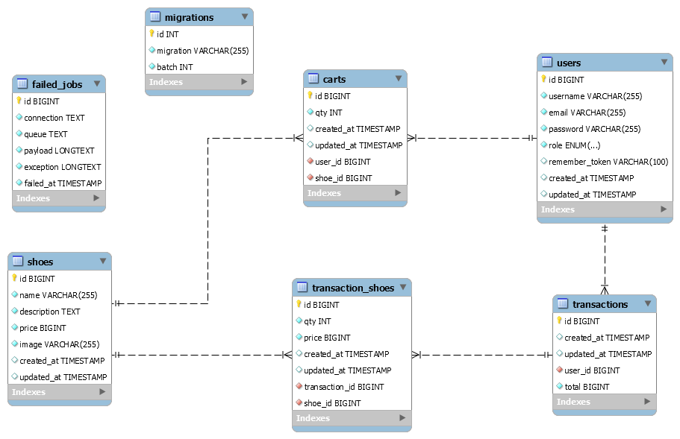

1. How to Run
2. Install all Laravel dependencies using **composer install**
3. Install dependencies for Laravel UI and Bootstrap 4 using **npm install** (optional, if you don’t need to modify the SCSS files, you can skip this step)
4. Run **php artisan storage:link** to enable server storage support (very important, otherwise the images won’t show up)
5. Set up your database connections in the **.env** file
6. Run **php artisan migrate** to push DB schema to your database of choice
7. Run **php artisan db:seed** to seed admin account and example shoes data
8. Start a local server with **php artisan serve** or your web server of choice
9. Admin Login

You can login to admin panel with the following credential (make sure you already ran all DB seeders using **php artisan db:seed**):

Email : admin@justduit.com

Password : 123456

1. Pages

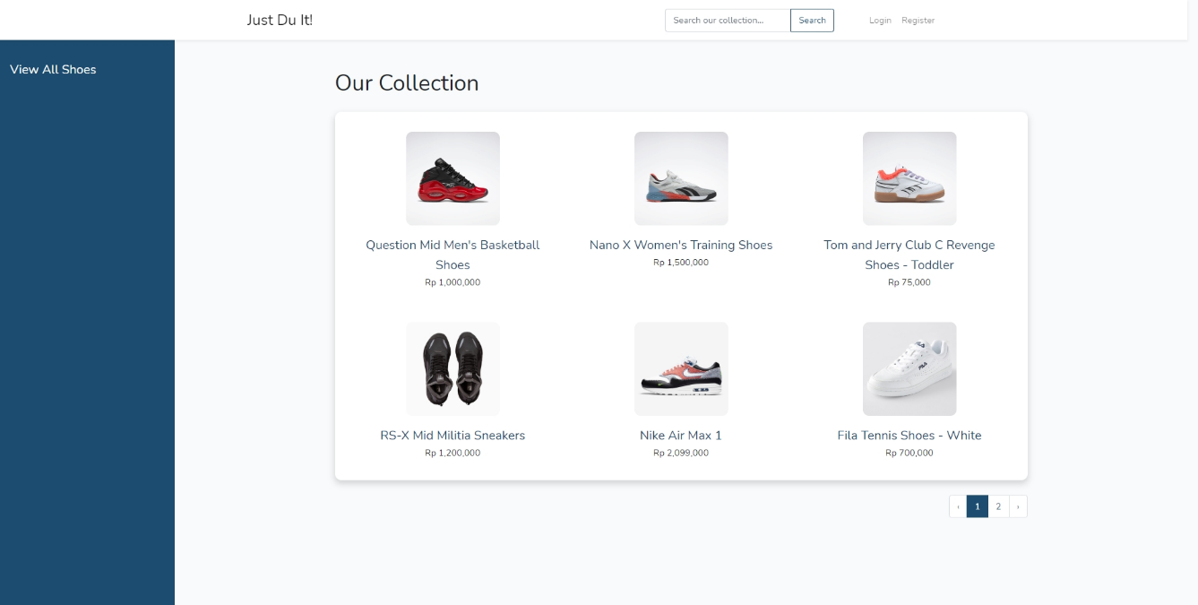

Home Page (Guest)

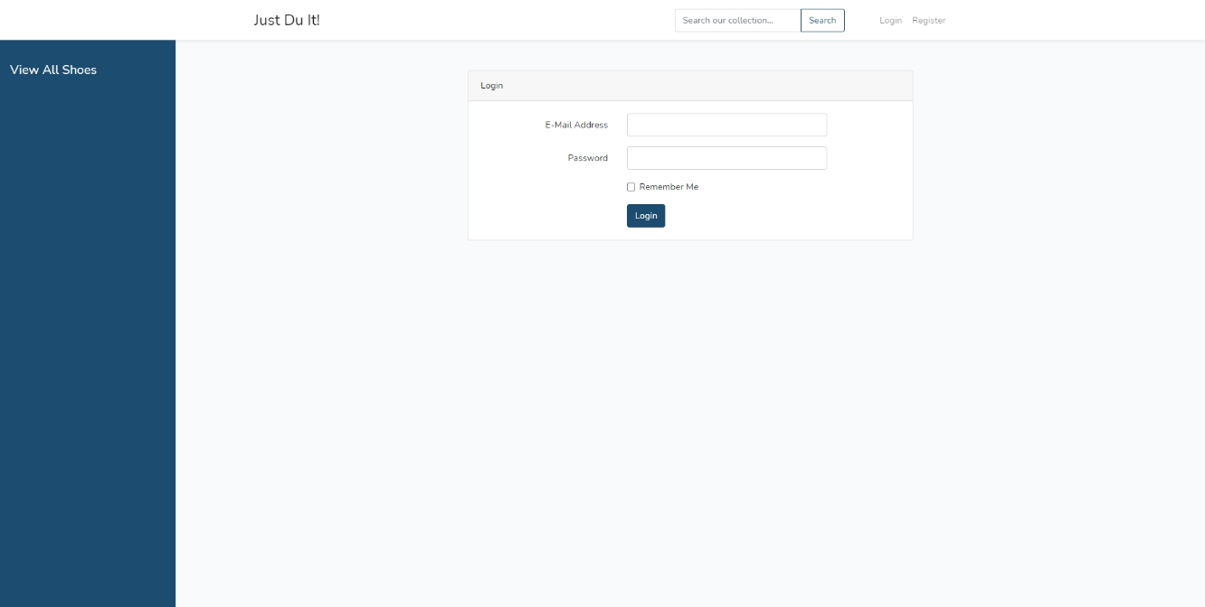

Login Page

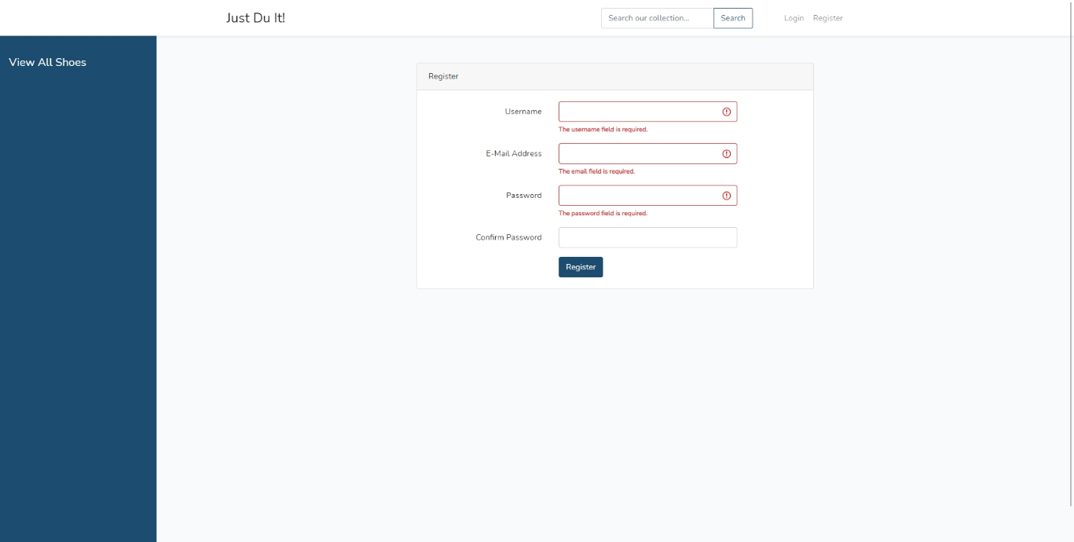

Register Page

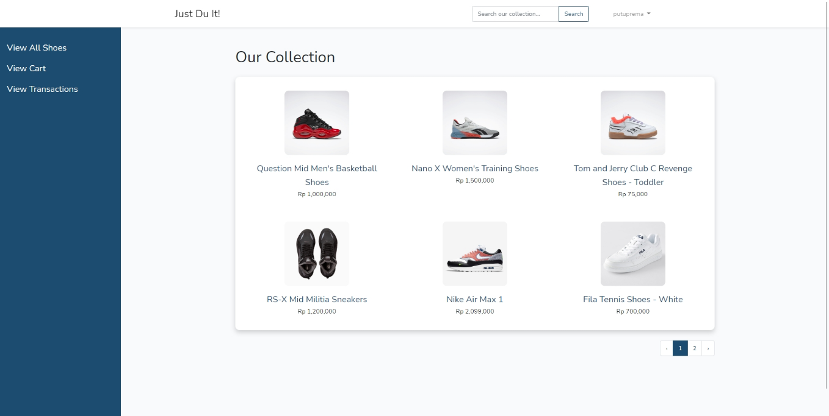

Home Page (Member)

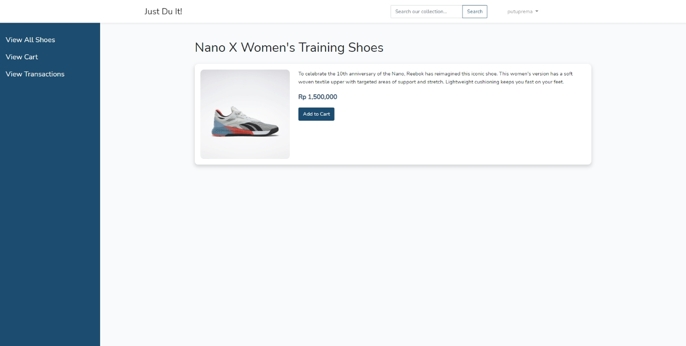

Shoes Details Page (Member)

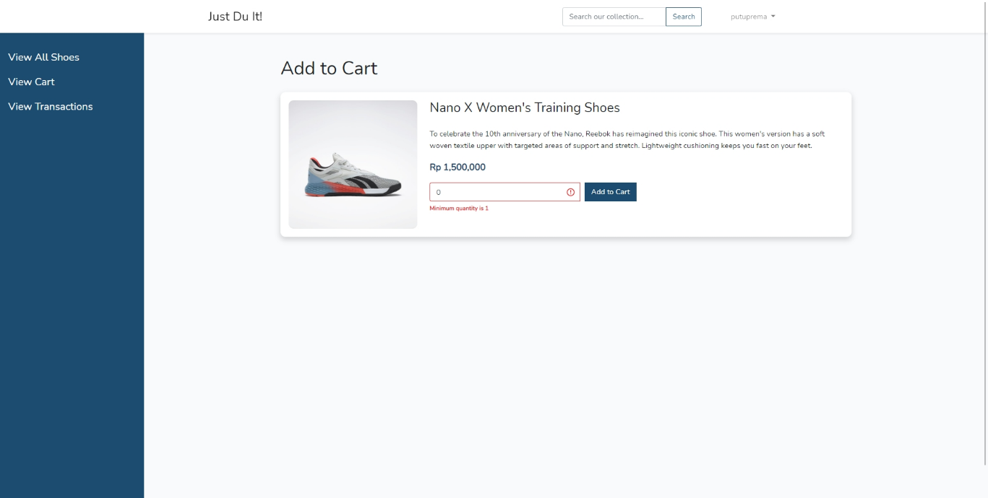

Add to Cart Page (Member)

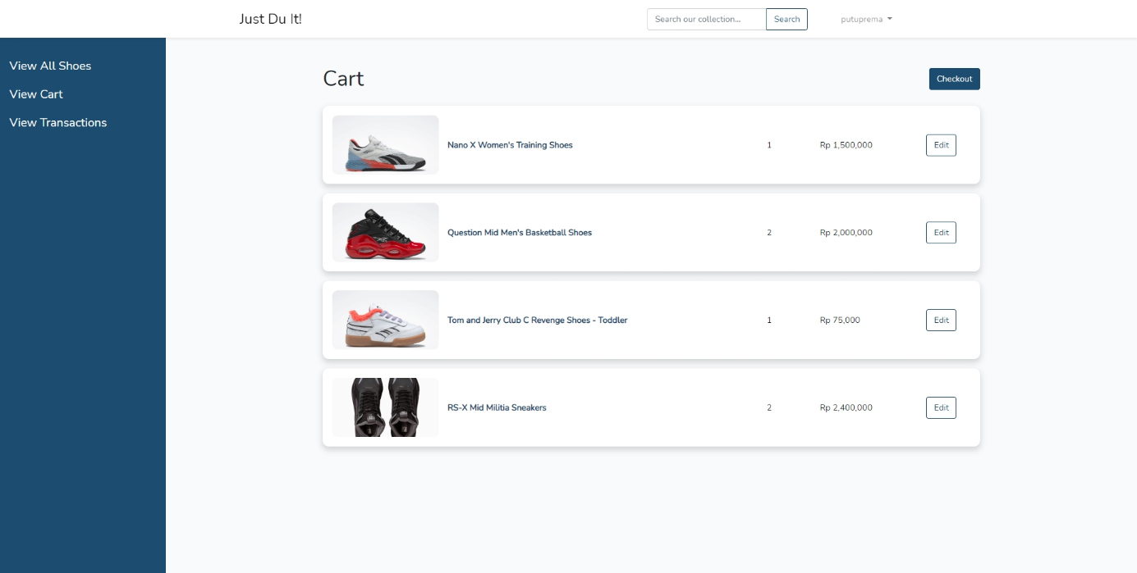

Cart Page (Member)

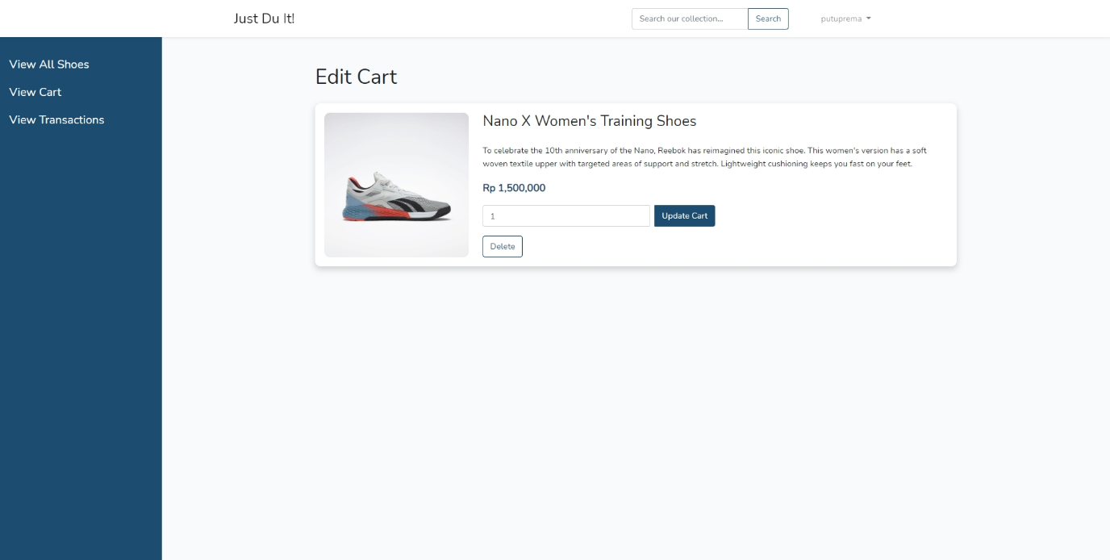

Edit Cart Page (Member)

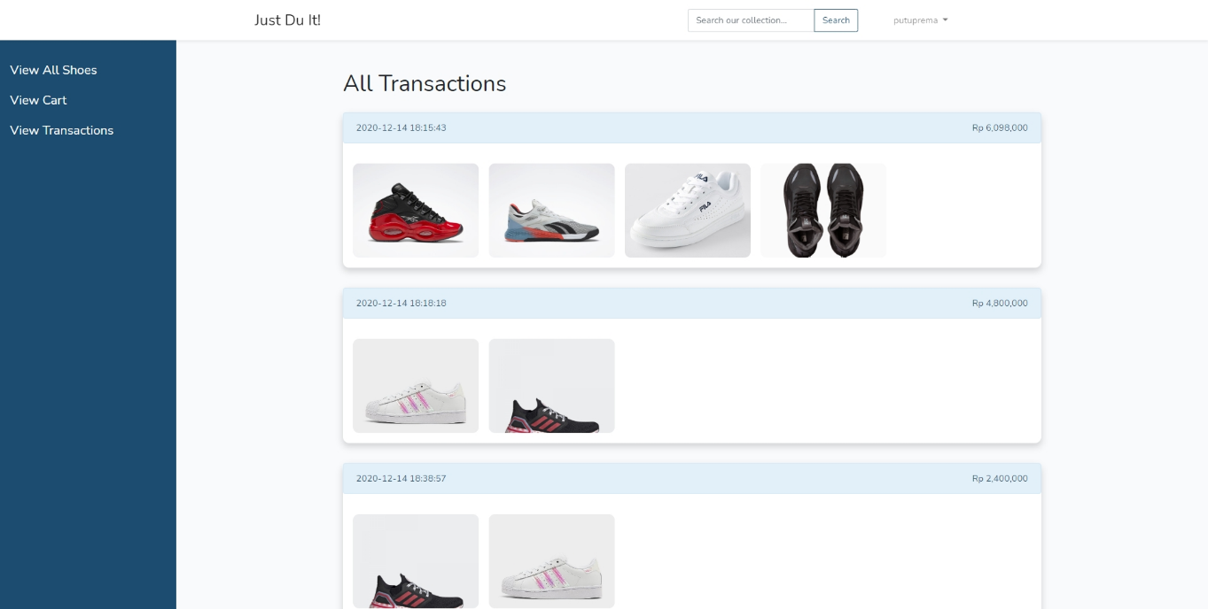

All Transactions Page (Member)

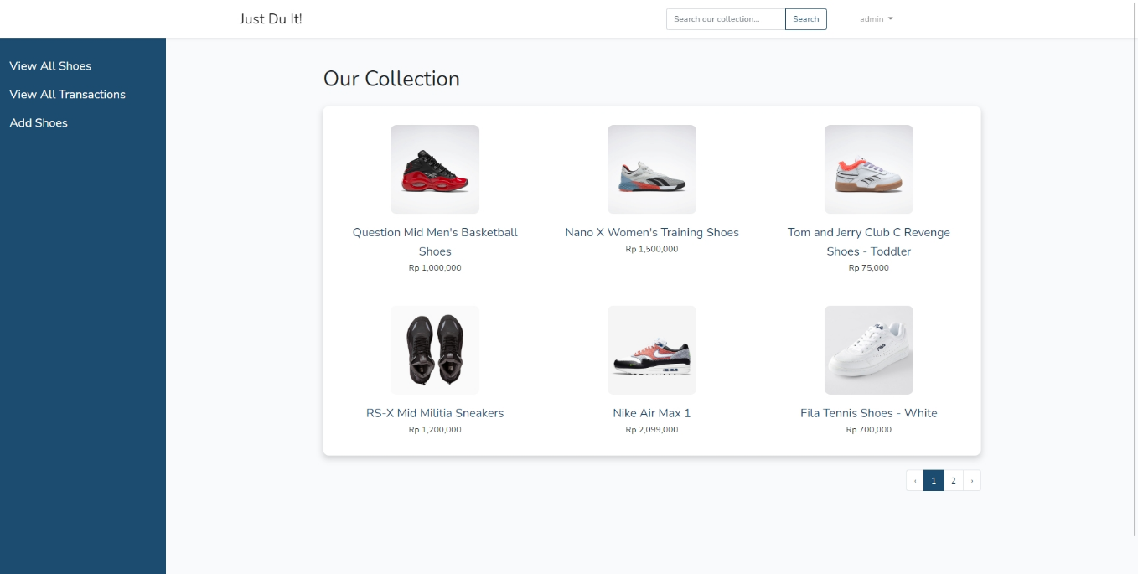

Home Page (Admin)

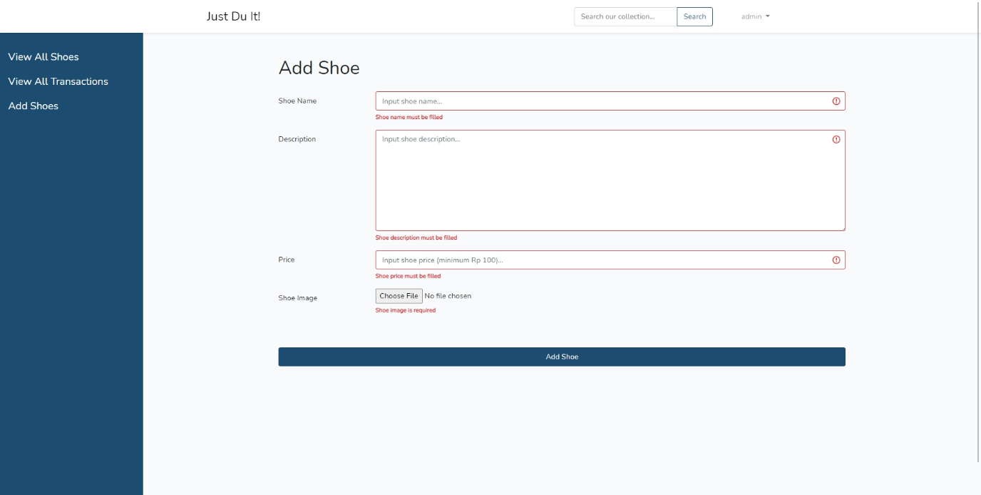

Add Shoes Page (Admin)

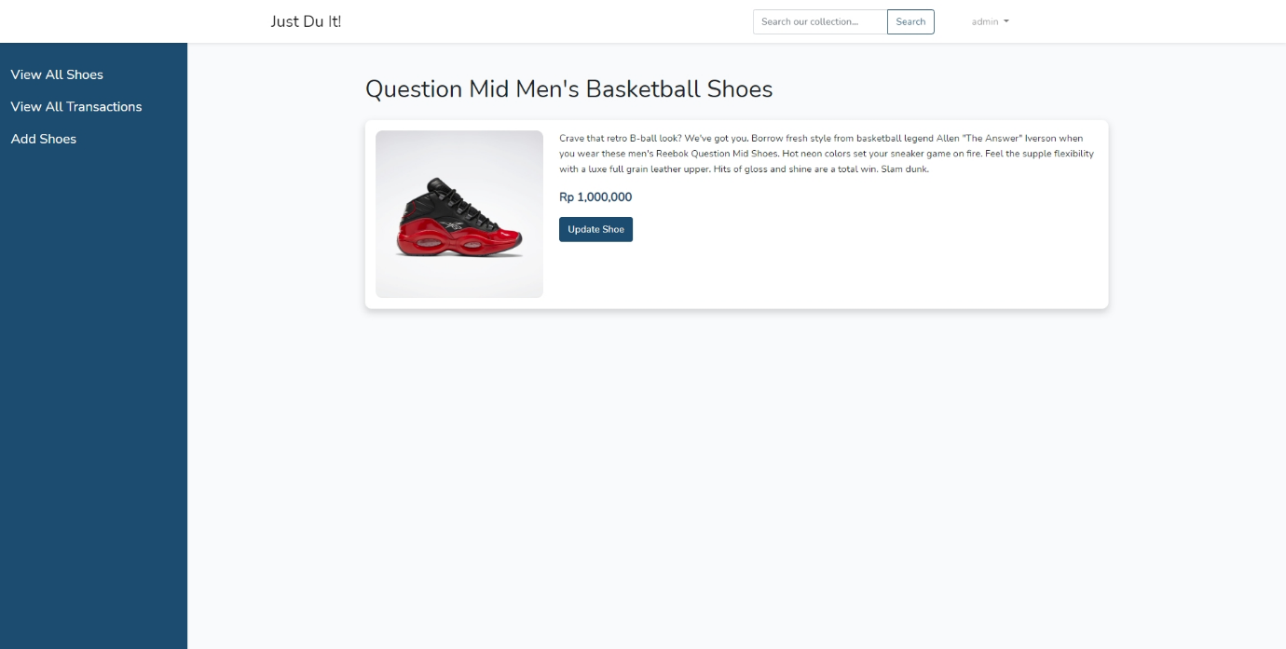

Shoes Details Page (Admin)

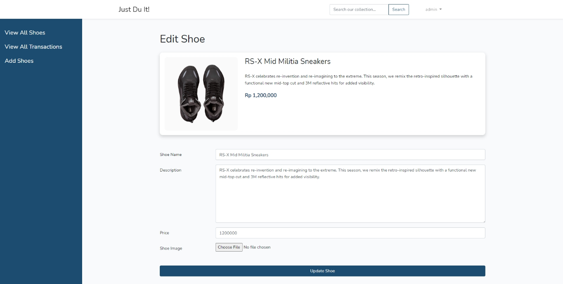

Edit Shoes Page (Admin)

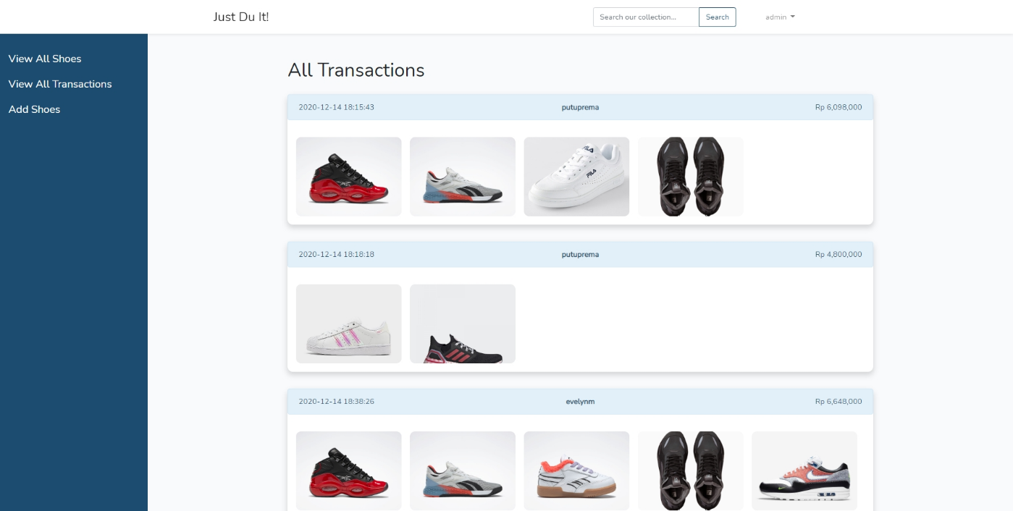

All Transactions Page (Admin)

* Reference
* <https://www.reebok.com/us/question-mid-mens-basketball-shoes/G57551.html>
* <https://www.reebok.com/us/reebok-nano-x-women-s-training-shoes/FY0670.html>
* <https://www.reebok.com/us/tom-and-jerry-club-c-revenge-shoes---toddler/H05214.html>
* <https://us.puma.com/en/us/pd/rs-x-mid-militia-sneakers/380414.html?dwvar_380414_color=01>
* <https://www.nike.com/id/t/air-max-1-shoe-SS9rJG/CT1643-100>
* <https://www.target.com.au/p/fila-tennis-shoes-white/62645997>
* <https://www.adidas.co.id/en/catalog/product/view/id/204161/>
* <https://www.finishline.com/store/product/girls-little-kids-adidas-originals-superstar-casual-shoes/prod802753>
* Group Member
* 2201785001 – I Putu Prema Ananda D.N